**CONTENTS**

TRAINING 1 2

A – 01.ADD 2

B – 01. SUBSEQMAX 2

C – ADDMOD 3

D – EXPMOD 3

E – SUMSEQ 4

F – WAY TOO LONG WORDS 4

KẾT QUẢ TRAINING 1 5

TRAINING 2 6

A – 02. HIST 6

B – 02. POSTMAN 6

C – 02. LOCATE 7

D – 02. WATERJUG BFS 7

E – 02. REROAD 8

F – 02. SIGNAL 8

G – SORT INT 9

H – PARENTHESES 9

KẾT QUẢ TRAINING 2 10

# **TRAINING 1**

## **A – 01.ADD**

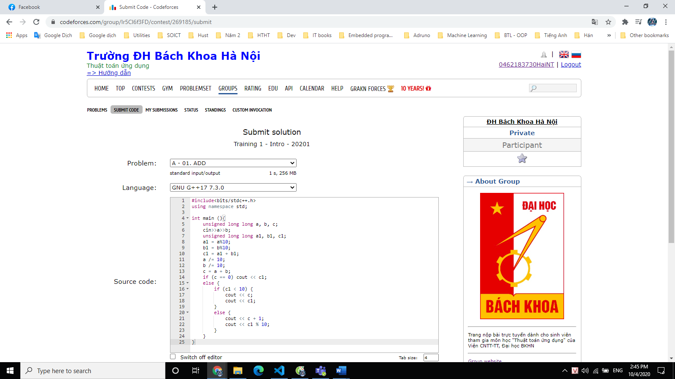

## **B – 01. SUBSEQMAX**

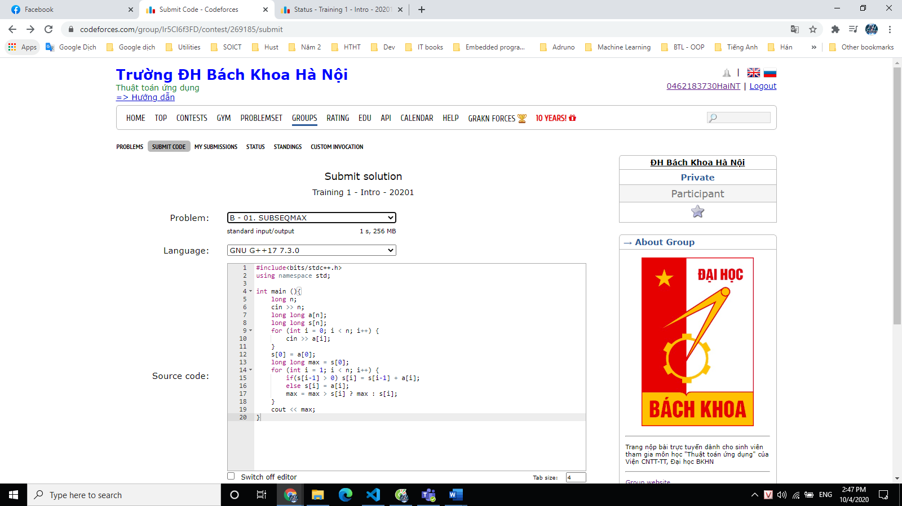

## **C – ADDMOD**

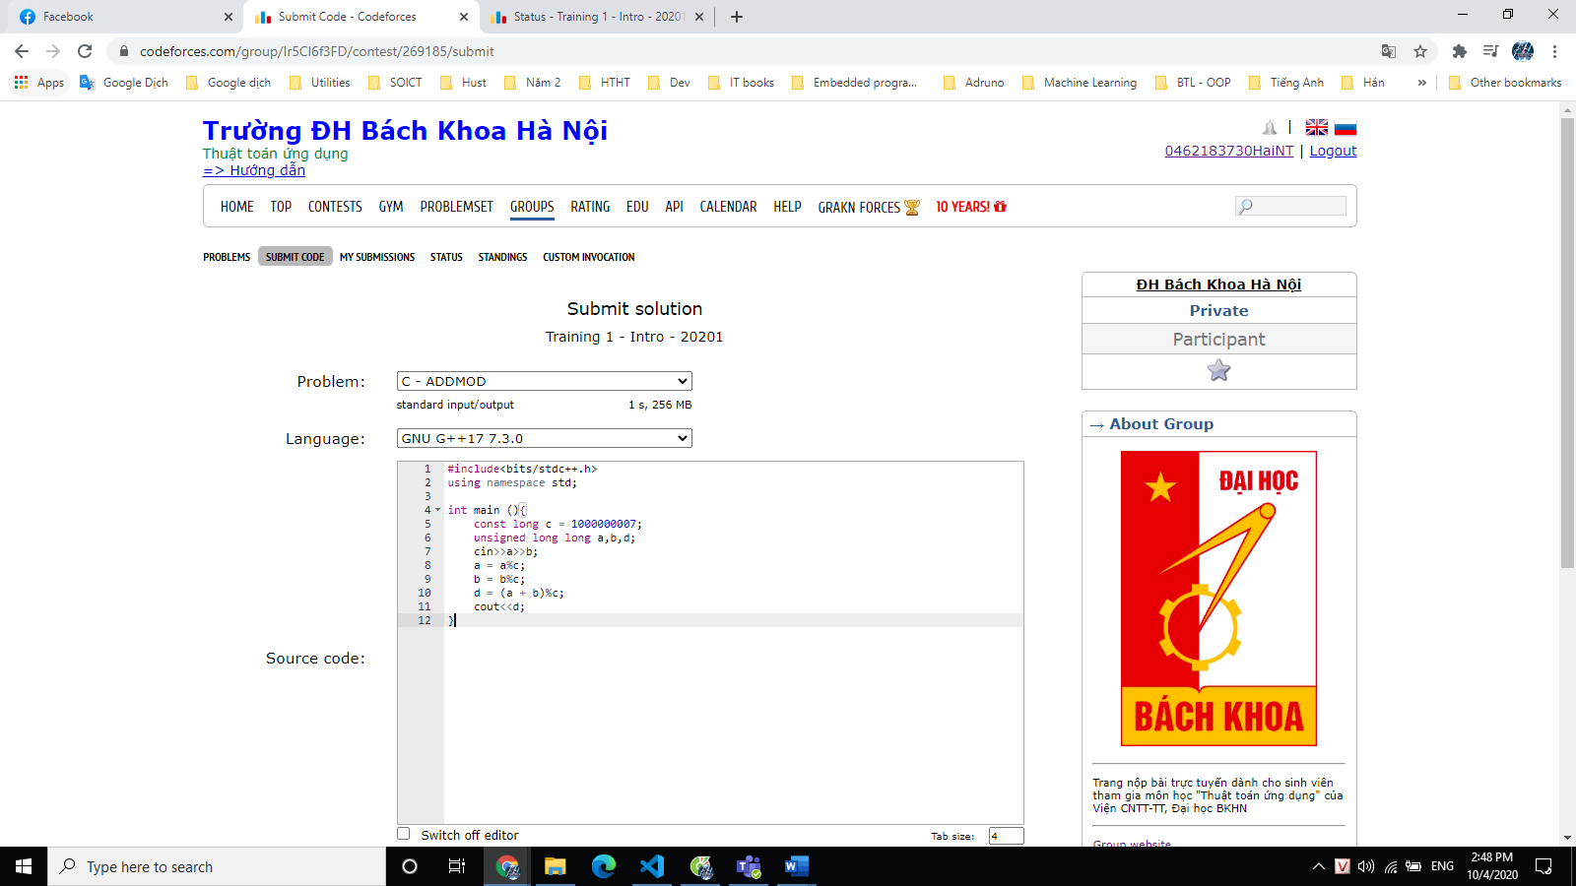

## **D – EXPMOD**

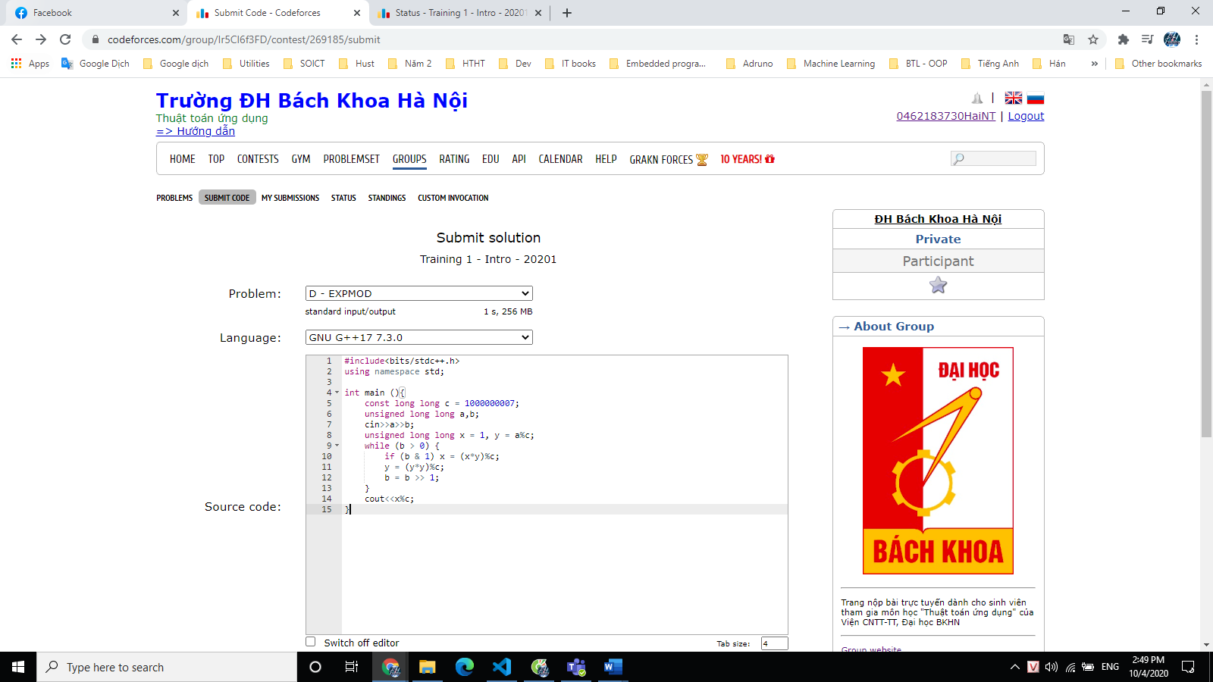

## **E – SUMSEQ**

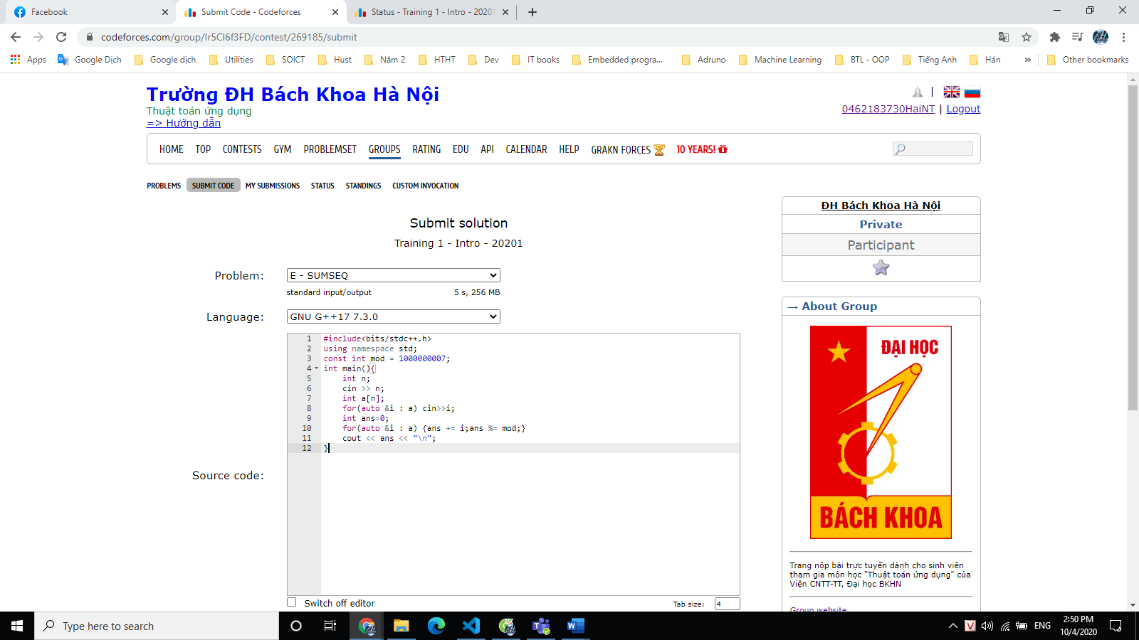

## **F – WAY TOO LONG WORDS**

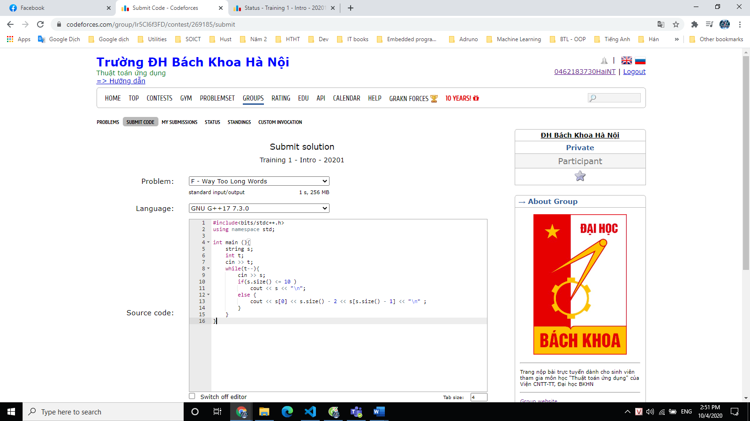

## **KẾT QUẢ TRAINING 1**

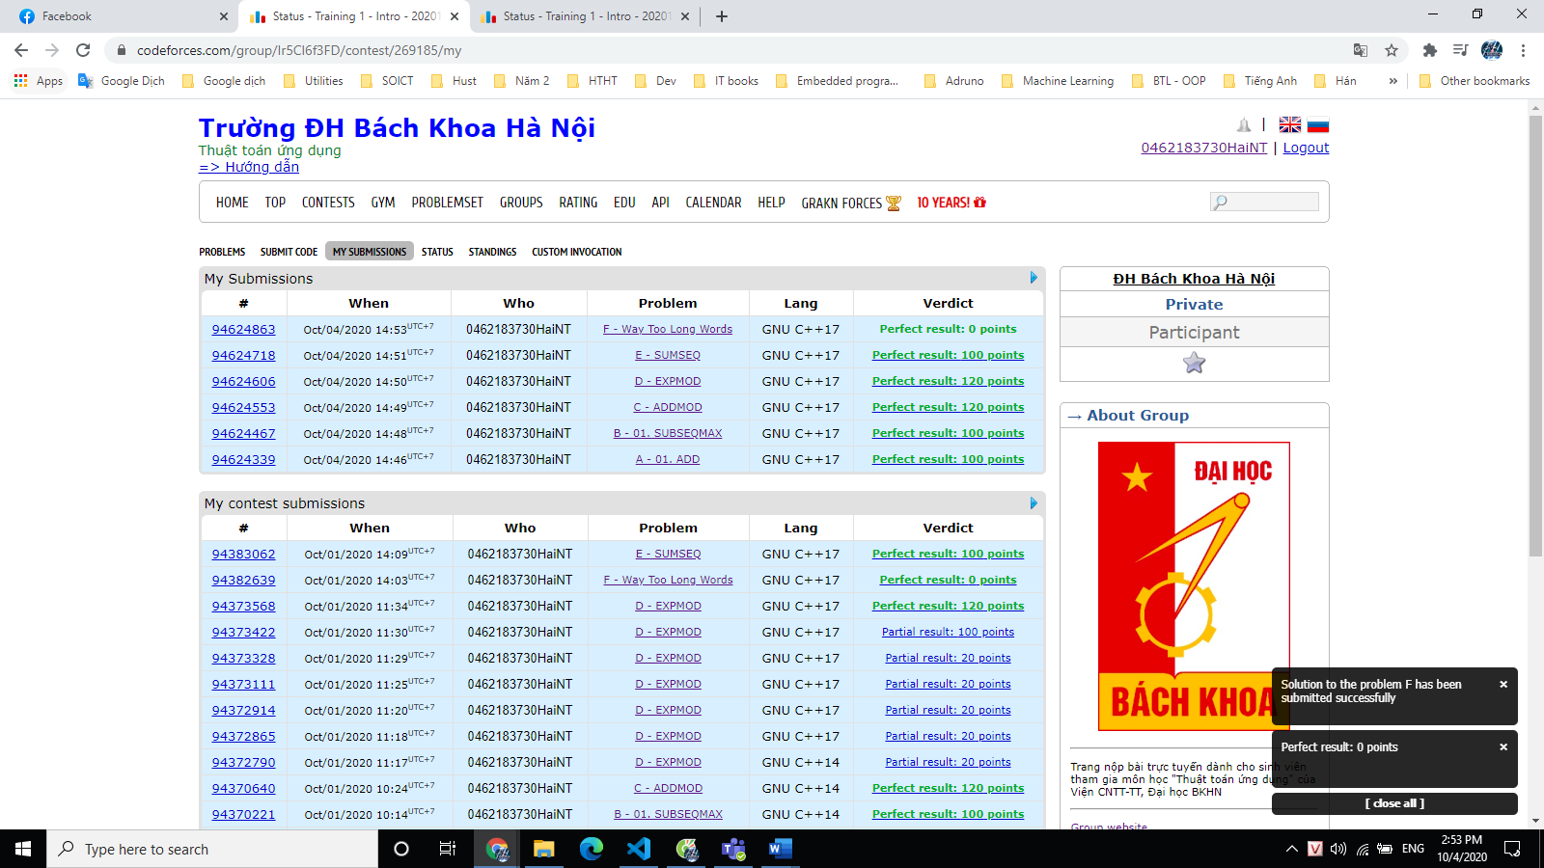

# **TRAINING 2**

## **A – 02. HIST**

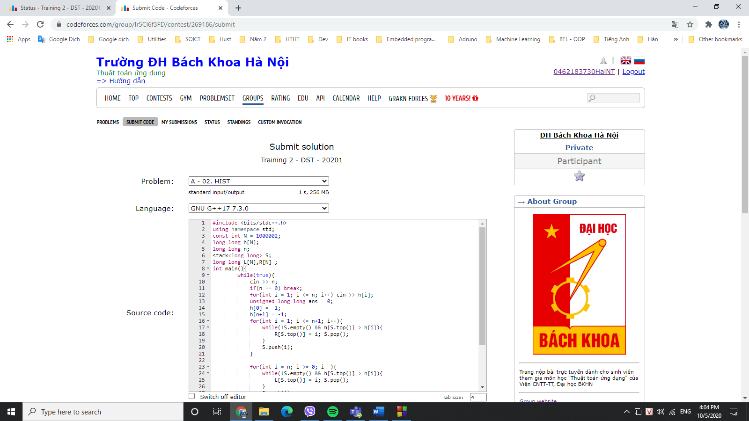

## **B – 02. POSTMAN**

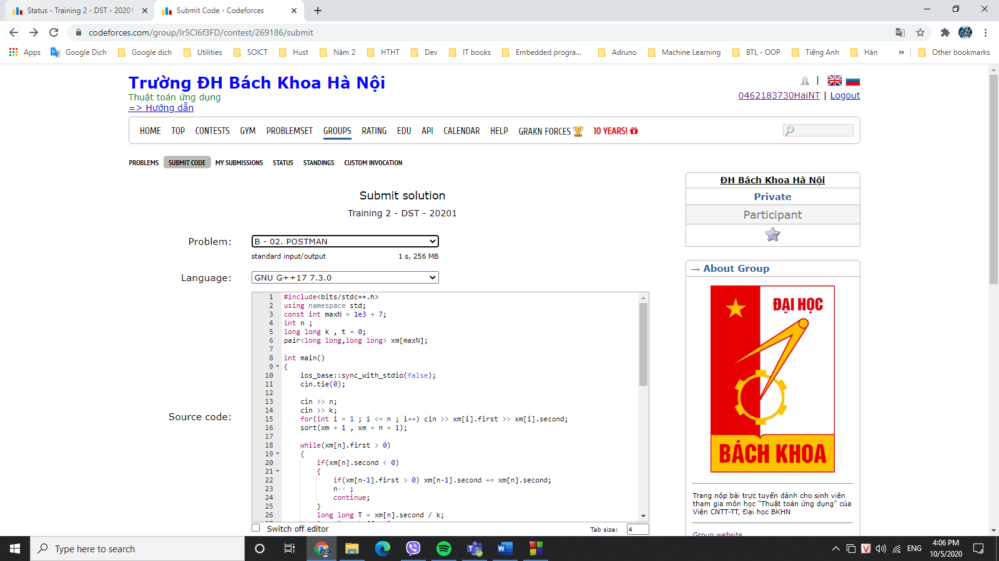

## **C – 02. LOCATE**

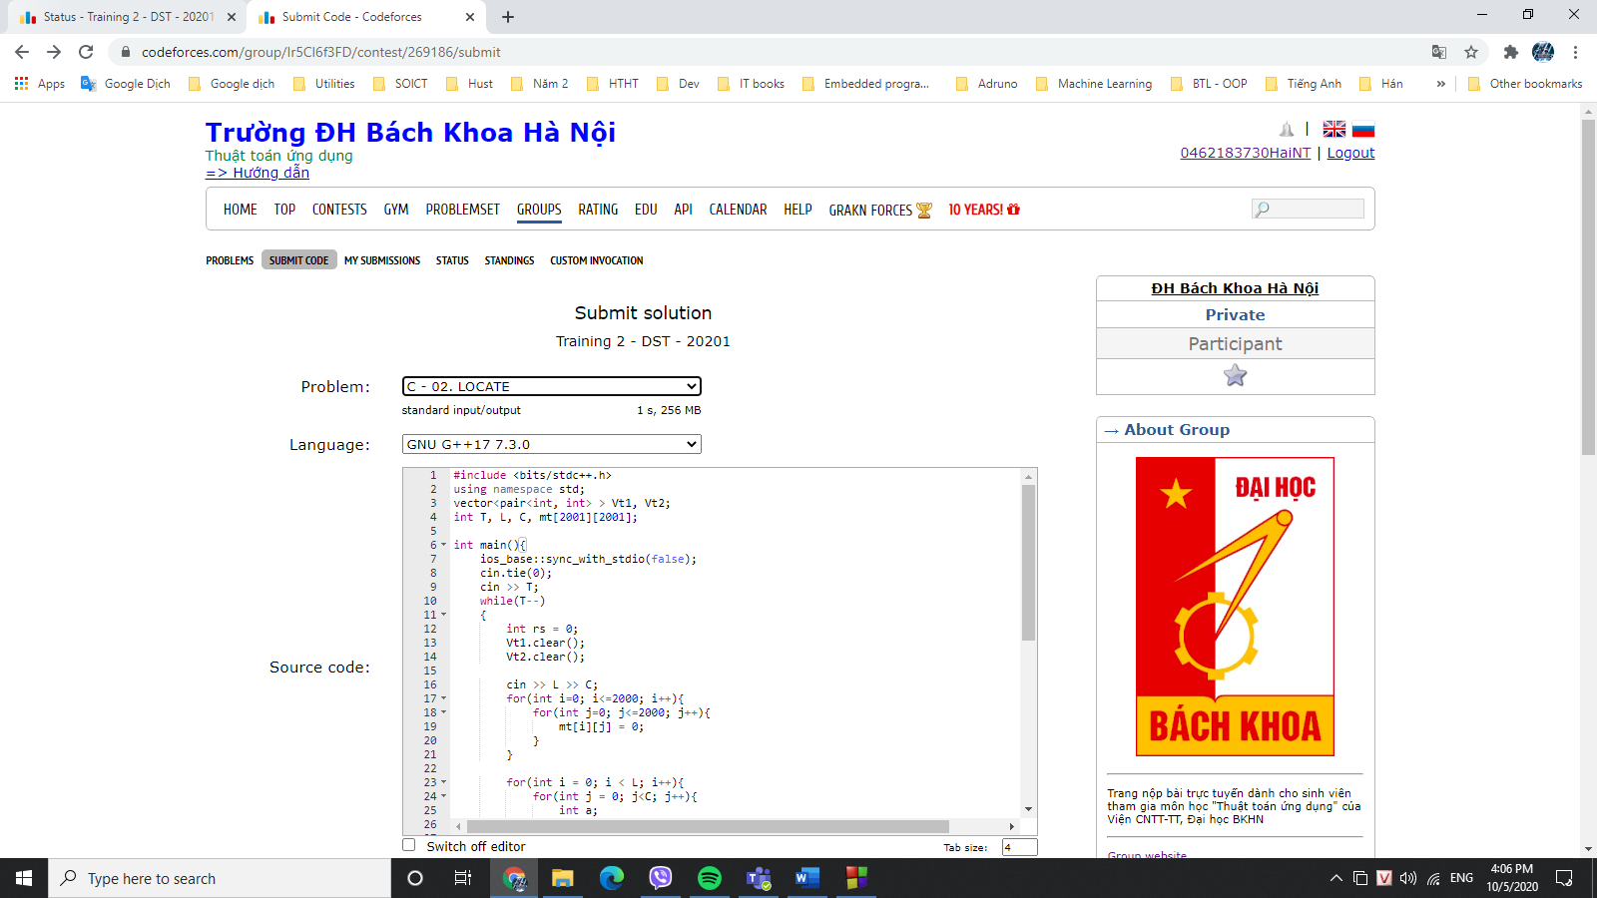

## **D – 02. WATERJUG BFS**

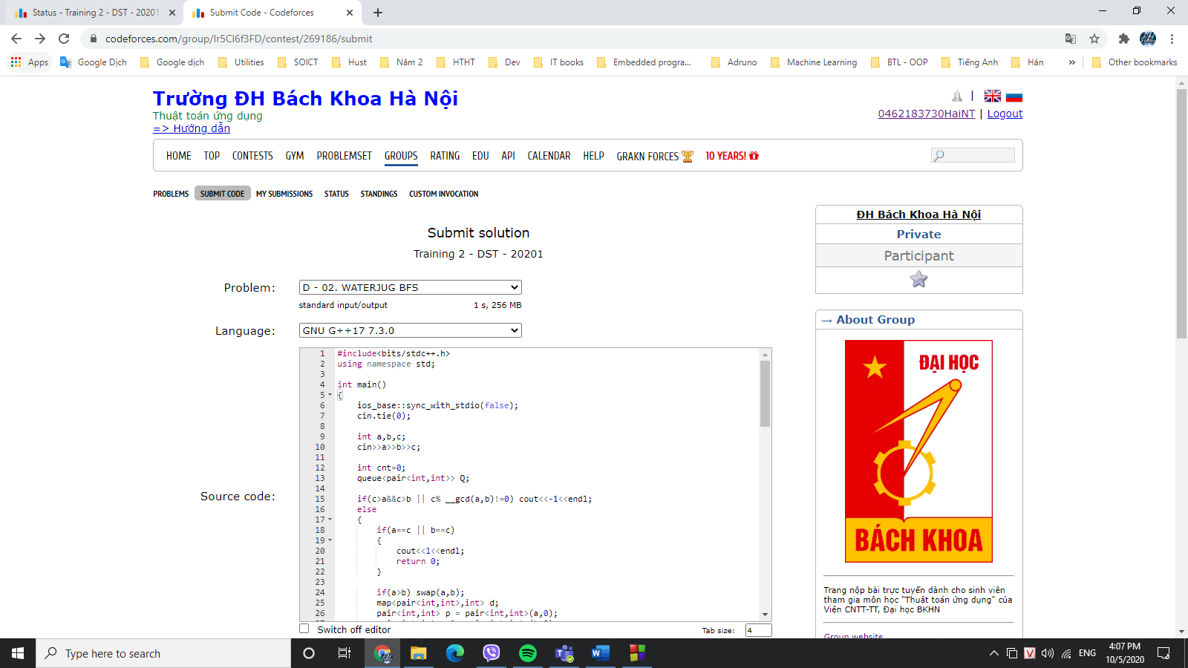

## **E – 02. REROAD**

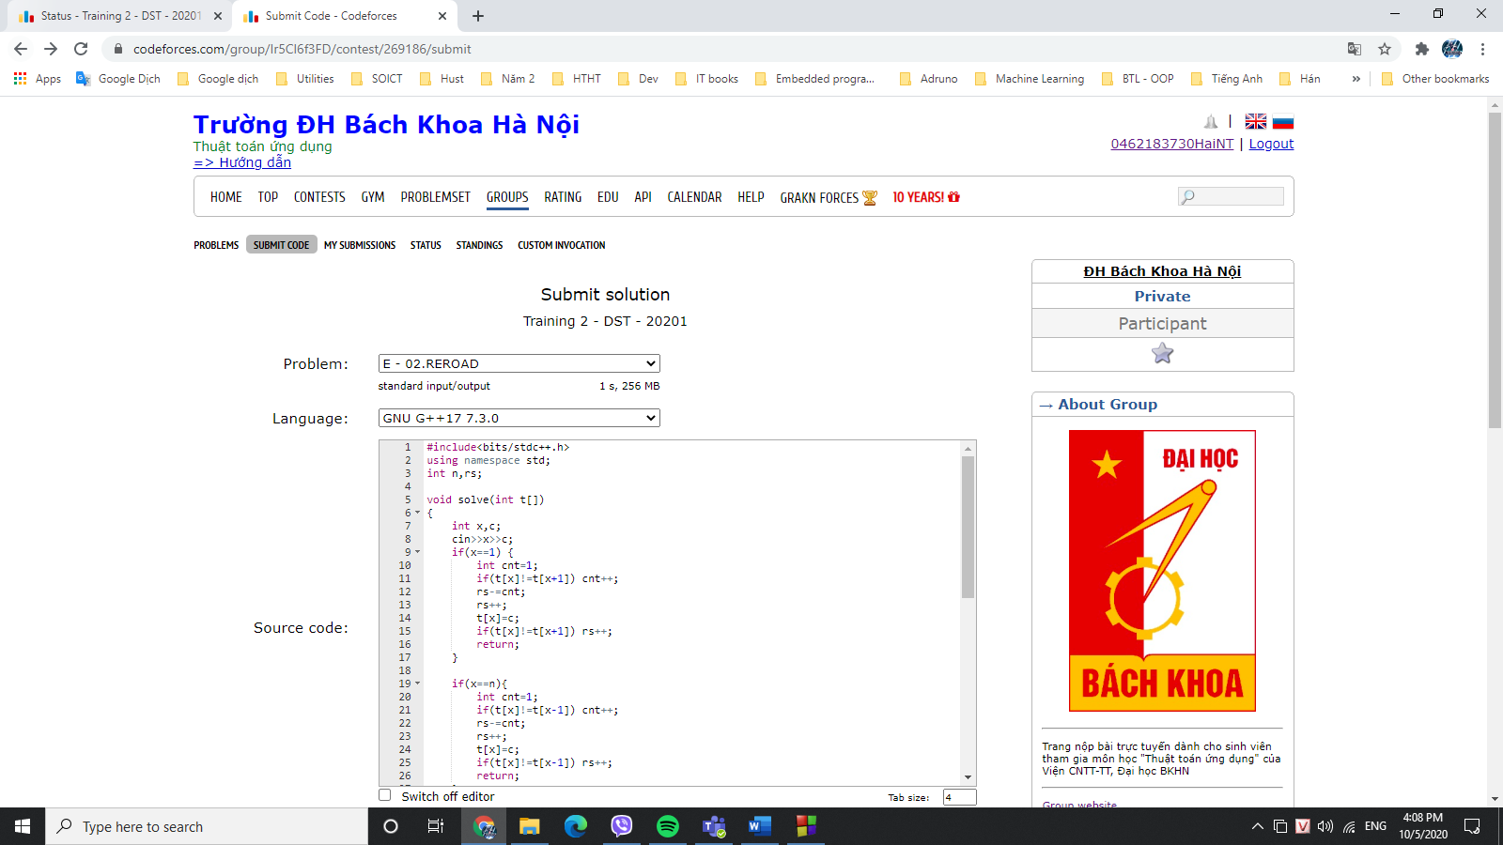

## **F – 02. SIGNAL**

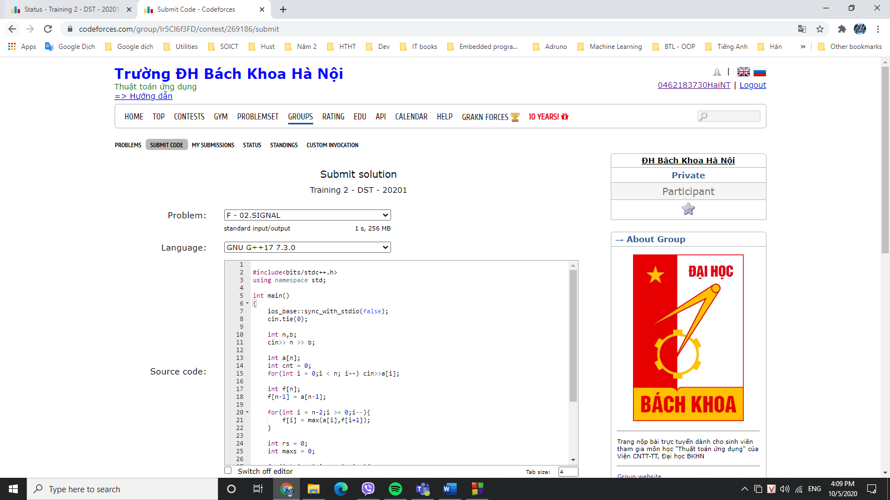

## **G – SORT INT**

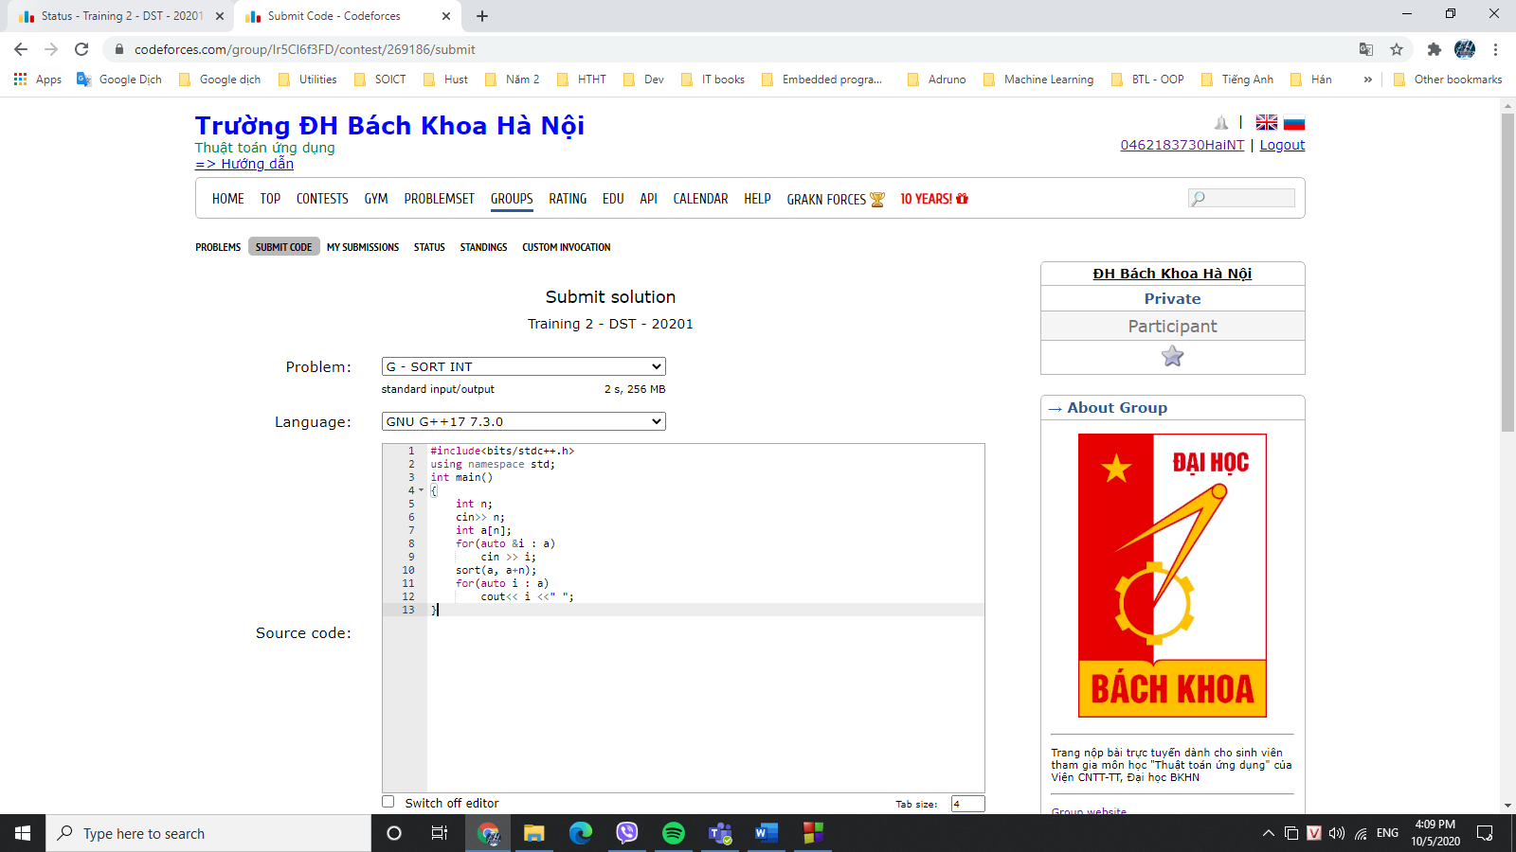

## **H – PARENTHESES**

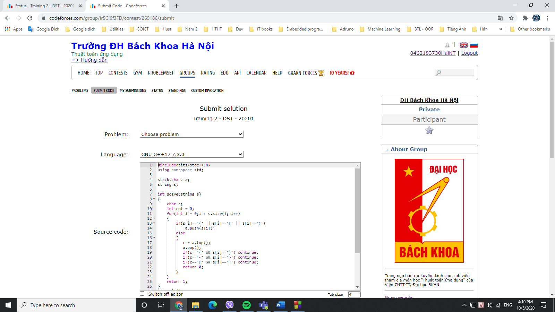

## **KẾT QUẢ TRAINING 2**

